Automated Plant Care System for Smart Homes Using IOT

Subrata Pain
Department of CSE
Alliance University
Anekal,Bengaluru-526106 Karnataka,India
subratabankata@gmail.com

Vuppu Surya Prakash
Department of CSE
Alliance University
Anekal,Bengaluru-526106 Karnataka,India svuppuBTECH22@ced.alliance.edu.in

Mogalipalle Hari Karthikeya
Department of CSE
Alliance University
Anekal,Bengaluru-526106
Karnataka,India
HmongalipalleBTECH22@ced.alliance.edu.in
Archita
Department of CSE
Alliance University
Anekal,Bengaluru-526106 Karnataka,India khongbantabamkarchitaBTECH22@ced.alliance.edu.in
M.V.S.Chaitanya
Department of CSE
Alliance University
Anekal,Bengaluru-526106
Karnataka,India
vmachirajuBTECH22@ced.alliance.edu.in

Abstract—The increasing adoption of smart home technologies, along with busy urban lifestyles, has created a growing need for automated and intelligent plant care solutions. Many homeowners struggle to maintain proper watering schedules for indoor and balcony plants, often resulting in overwatering or underwatering. Traditional manual watering methods lack consistency and fail to adapt to changing environmental conditions such as temperature, humidity, and seasonal variations.This research proposes an intelligent Machine Learning (ML)–based Internet of Things (IoT) Smart Home Plant Care System designed to optimize watering decisions and improve plant health through automated control. The system employs IoT sensors to continuously monitor critical parameters such as soil moisture, ambient temperature, humidity, water tank levels, and real-time weather conditions. Historical sensor data and watering patterns are used to train machine learning models capable of predicting optimal watering requirements and pump activation probabilities.Weather-aware predictive logic is incorporated to prevent unnecessary watering during high humidity or rainy conditions. The framework integrates automated pump control with a Flask-based web application that provides real-time monitoring, predictive analytics, alert notifications, and system management. Experimental evaluation demonstrates improved water-use efficiency, stable soil moisture maintenance, accurate prediction performance, and low operational latency. The proposed solution offers a scalable, cost-effective, and intelligent approach for smart home plant automation, enhancing plant health while conserving water resources.

Keywords— Smart Home Automation, Internet of Things (IoT), Plant Monitoring, Automated Watering System, Machine Learning, Predictive Analytics, Soil Moisture Sensing, Weather-Aware Control, Flask Web Application.

Introduction
Indoor and balcony plants play an important role in improving air quality, enhancing home aesthetics, and promoting mental well-being. However, maintaining healthy plants requires consistent monitoring of soil moisture and environmental conditions. Many homeowners rely on manual watering or fixed schedules, which often lead to overwatering, underwatering, root damage, soil instability, and unnecessary water wastage. These traditional approaches lack adaptability and do not account for changes in temperature, humidity, or seasonal variations within indoor environments.
Environmental factors such as room temperature, humidity levels, sunlight exposure, and weather conditions significantly influence plant water requirements.

In most homes, watering decisions are based on guesswork rather than data-driven insights, resulting in inefficient plant care. With increasing interest in smart home automation and sustainable living, there is a growing need for intelligent plant care systems capable of adapting to real-time environmental conditions.
The Internet of Things (IoT) enables continuous monitoring of plant conditions through interconnected sensors that measure soil moisture, ambient temperature, humidity, and water tank levels. IoT-based plant monitoring systems provide real-time insights; however, many existing solutions rely on simple threshold-based control logic, where watering is triggered when soil moisture falls below a fixed value. While easy to implement, such systems lack adaptability, fail to capture long-term moisture trends, and do not consider environmental interactions or weather forecasts.
Machine learning offers a powerful approach to overcome these limitations by learning complex patterns from historical sensor data. ML models can analyze temporal variations, nonlinear relationships, and interactions between environmental parameters to predict watering needs more accurately. When combined with IoT monitoring and weather information, ML-based systems can significantly improve watering efficiency and overall plant health.
This research proposes an end-to-end Smart IoT-Based Home Plant Care System integrated with machine learning-based prediction and automated decision-making. The system performs real-time monitoring, predictive watering control, and intelligent pump activation. A secure Flask-based web interface provides visualization, manual control, prediction insights, and system diagnostics. The proposed framework is scalable, cost-effective, and well-suited for smart home environments.

LITERATURE SURVEY

Smart plant monitoring and automated watering systems have evolved significantly over the past decade, driven by advancements in sensing technologies, wireless communication, embedded systems, and intelligent data processing techniques. Early plant automation systems were primarily rule-based, operating on fixed soil moisture thresholds, predefined watering intervals, or manually configured schedules. Although such systems reduced human effort and enabled basic automation, they lacked adaptability to fluctuating indoor environmental conditions such as temperature variations, humidity changes, and seasonal transitions. As a result, these systems often caused overwatering or underwatering, negatively affecting plant health.

The integration of the Internet of Things (IoT) introduced a major transformation in smart home plant monitoring by enabling continuous, real-time environmental sensing through interconnected sensor networks. IoT-based plant care systems use low-power sensors and microcontrollers to measure soil moisture, ambient temperature, humidity, light intensity, and water availability. Data collected from these sensors can be transmitted wirelessly to cloud platforms for storage and remote monitoring. Xu et al. [1] presented a foundational IoT framework supporting distributed sensing and scalable monitoring architectures, which laid the groundwork for modern smart monitoring systems. Ayaz et al. [2] further demonstrated the effectiveness of IoT-based systems in enabling real-time environmental monitoring and automated control.
Despite their effectiveness in data acquisition, many IoT-only plant monitoring systems rely on static threshold-based decision logic. Such systems trigger watering when soil moisture falls below a predefined value. While simple and cost-effective, this approach fails to capture complex and nonlinear relationships between soil moisture, temperature, humidity, and environmental dynamics. Ray [3] emphasized that IoT systems must integrate intelligent analytics to move beyond reactive automation toward predictive decision-making.
To overcome these limitations, researchers have increasingly incorporated machine learning (ML) techniques into smart plant care frameworks. Liakos et al. [4] reviewed machine learning applications in environmental monitoring and highlighted predictive irrigation scheduling as a key area where ML models outperform rule-based systems. Machine learning models learn from historical sensor data, adapt to changing conditions, and make proactive predictions instead of reactive responses.
Various supervised learning algorithms have been explored for watering prediction, including Linear Regression, Support Vector Machines, k-Nearest Neighbors, Artificial Neural Networks, and decision tree-based methods. García et al. [5] demonstrated that predictive models significantly improve watering efficiency compared to traditional threshold-based approaches. Rahman et al. [6] showed that integrating IoT sensor data with ML models improves watering accuracy and reduces water wastage.
Among the available algorithms, ensemble learning methods such as Random Forest and Gradient Boosting have gained attention due to their robustness, high prediction accuracy, and ability to handle noisy sensor data. These models effectively capture nonlinear interactions between soil moisture, temperature, and humidity, making them suitable for smart home plant care environments.
Weather-aware watering control has also emerged as an important research direction. Integrating weather forecasts and humidity predictions into watering logic prevents unnecessary irrigation during high-moisture conditions. López-Mata et al. [7] demonstrated that weather-based scheduling significantly improves water-use efficiency. However, many systems rely on heuristic rules rather than predictive machine learning models, limiting adaptability.
Recent research has focused on combining IoT sensor data, cloud platforms, and predictive analytics within unified frameworks. Kamilaris and Prenafeta-Boldú [8] highlighted the growing importance of deep learning and data-driven models in smart monitoring applications. Ferentinos [9] further demonstrated the effectiveness of advanced ML models in plant health monitoring tasks.
System deployment and scalability remain important challenges. Many smart plant monitoring solutions are prototype-based and lack scalable web interfaces. Sharma et al. [10] emphasized the role of lightweight frameworks such as Flask in deploying ML-enabled IoT systems with real-time dashboards and remote control capabilities.
Security and data integrity have also become critical concerns in IoT-based smart home systems. Unauthorized access and data manipulation can compromise system reliability. Therefore, modern implementations incorporate authentication mechanisms, secure APIs, and encrypted communication protocols to ensure system stability.
Another limitation in existing systems is the absence of automated model retraining mechanisms. As environmental patterns change over time, static ML models may lose prediction accuracy. Continuous learning frameworks that periodically retrain models using newly collected sensor data help maintain long-term performance and adaptability.
This study addresses the identified research gaps by proposing a comprehensive Smart Home IoT-Based Plant Care System that integrates real-time sensing, machine learning-based predictive watering, weather-aware logic, automated pump control, secure communication mechanisms, and a scalable Flask-based web deployment architecture. The proposed system provides an intelligent, adaptive, and practical solution for automated home plant care while improving water efficiency and plant health.

Methodology

The proposed Smart Home IoT-Based Plant Care System follows a multi-stage methodology integrating real-time environmental monitoring, intelligent data processing, machine learning–based prediction, automated watering control, and web-based deployment. The overall workflow is designed to ensure accurate watering decisions, efficient water usage, and reliable system operation within indoor and residential environments.

- Data Collection and Preprocessing
Environmental and operational data are continuously collected using IoT sensors installed near indoor or balcony plants. The sensing layer monitors essential parameters such as soil moisture, ambient temperature, relative humidity, water tank level, pump status, and watering duration. These sensors are connected to low-power microcontrollers that transmit data to the backend server at predefined intervals using wireless communication protocols such as Wi-Fi.
In addition to sensor data, external weather information—including rainfall probability, humidity forecasts, and temperature predictions—is obtained through weather APIs. Integrating real-time and forecast-based weather data enables proactive watering decisions and prevents unnecessary watering during humid or rainy conditions.
Raw sensor readings may contain noise, missing values, or temporal inconsistencies caused by sensor inaccuracies, network delays, or environmental disturbances. To ensure data reliability and model accuracy, a preprocessing pipeline is implemented, consisting of the following steps:
- Handling missing or corrupted sensor values using interpolation or removal techniques
- Noise reduction through smoothing and filtering methods
- Normalization and scaling of continuous features to maintain consistent model inputs
- Time-based feature extraction (e.g., hour of day, day of week) to capture watering patterns
- Synchronization of sensor readings with corresponding weather data
- Encoding categorical variables such as pump status into numerical form
This preprocessing stage ensures data consistency, improves model performance, and enhances the reliability of real-time prediction and automated watering decisions.

Fig. 1. Workflow of the Proposed ML-Based Smart Home IoT Plant Care System
- Feature Engineering
Feature engineering plays a critical role in improving the predictive performance of the plant watering models. In addition to raw sensor readings, several derived features are generated to capture temporal patterns, indoor environmental interactions, and soil moisture behavior over time.
Time-based features such as hour of the day and day of the week are extracted to model daily watering patterns commonly observed in indoor environments. Soil moisture trends are calculated using rolling averages and rate-of-change indicators to capture short-term fluctuations and gradual drying patterns. These features help the model understand how quickly the soil loses moisture under varying indoor conditions.
Interaction features are created by combining temperature, humidity, and soil moisture values to better represent plant water absorption dynamics and indoor evapotranspiration effects. Weather-related indicators such as rainfall probability, forecasted humidity levels, and temperature predictions are also incorporated to prevent unnecessary watering during high-moisture conditions.
These engineered features provide richer contextual information, enabling the machine learning models to learn complex relationships between environmental conditions and plant watering requirements more effectively.

- Machine Learning Model Training
Supervised machine learning models are trained using historical sensor data, weather information, and recorded watering actions. The dataset is divided into training and testing subsets to ensure unbiased model evaluation and generalization.Ensemble learning algorithms such as Random Forest and Gradient Boosting are employed due to their robustness, high predictive accuracy, and ability to handle nonlinear relationships and noisy IoT sensor data. These models are well-suited for smart home environments where sensor readings may vary due to indoor disturbances.
The models are trained to predict watering necessity (Yes/No) and estimate pump activation probability based on current and forecasted environmental conditions. Hyperparameter tuning is performed to optimize performance, and feature importance analysis is conducted to identify the most influential factors affecting watering decisions. This enhances model interpretability and supports system transparency.
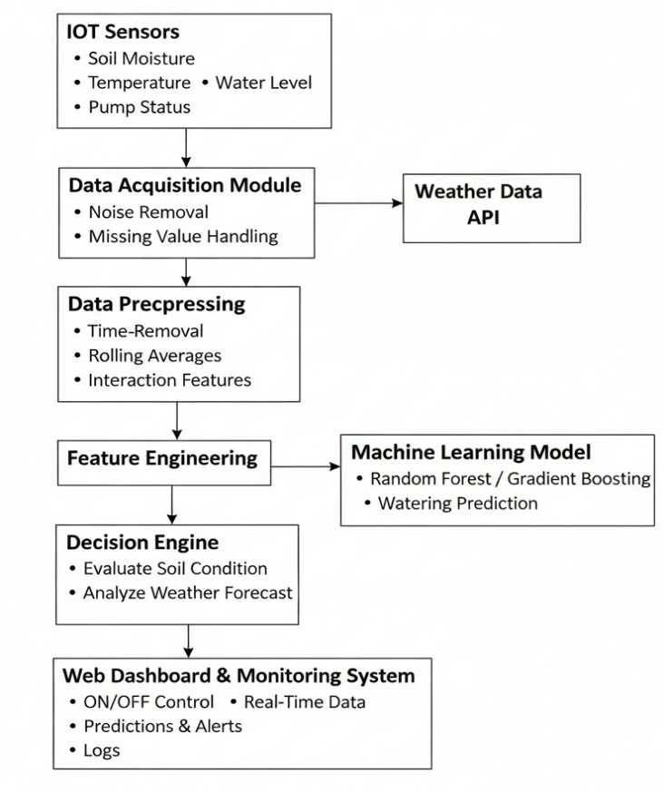
- Model Evaluation
Model performance is evaluated using multiple classification metrics, including accuracy, precision, recall, F1-score, and confusion matrix analysis.
Special emphasis is placed on minimizing:
- False positives (unnecessary pump activation and water wastage)
- False negatives (missed watering events that may stress plants)
In addition to standard evaluation metrics, prediction consistency and stability over time are analyzed to ensure reliable performance under changing indoor environmental conditions. Cross-validation techniques are used to validate model robustness and generalization across different time periods.

- Automated Control and Web-Based Deployment
The trained machine learning models are deployed within a Flask-based backend system that performs real-time inference using incoming sensor and weather data. Based on model predictions, the system automatically activates the water pump through actuator interfaces, ensuring timely and efficient watering.
A web-based application provides an interactive interface for homeowners and administrators, offering:
- Real-time sensor monitoring
- Historical watering data visualization
- ML-based watering prediction results
- System configuration settings
- Alert notifications
- Manual override controls
The modular and scalable architecture allows easy integration of additional sensors, advanced models, mobile applications, or cloud-based services in future upgrades. This ensures adaptability and long-term usability within smart home environments.
.

- IMPLEMENTATION

The proposed Smart Home IoT-Based Plant Care and Monitoring System is implemented as a complete end-to-end solution integrating IoT-based sensing, machine learning-driven prediction, automated watering control, weather integration, and a web-based monitoring interface. The implementation emphasizes real-time usability, scalability, low-cost deployment, and reliability, making it suitable for indoor plants, balcony gardens, and residential smart home environments.

- System Architecture
The system follows a layered client–server architecture consisting of three primary layers: the Sensing Layer, Application Layer, and Data Layer. This modular design enhances maintainability, scalability, and fault tolerance.
Sensing Layer (IoT Layer)
This layer consists of IoT sensors placed near indoor or balcony plants to continuously monitor:
- Soil moisture
- Ambient temperature
- Relative humidity
- Water tank level
- Pump status
Sensor readings are transmitted periodically to the backend server using Wi-Fi-based HTTP communication. These values represent the real-time environmental state of the plant and serve as the foundation for automated watering decisions.
Application Layer (Backend Processing)
The application layer is implemented using Python and the Flask web framework. It handles:
- Sensor data ingestion
- Machine learning inference
- Watering decision logic
- Weather data integration
- Pump control operations
The backend exposes RESTful API endpoints to receive sensor data, trigger predictions, control the water pump, and provide data to the frontend dashboard.
Data Layer (Storage and Logging)
A lightweight SQLite database is used for persistent storage of:
- Sensor readings
- Watering actions
- Weather information
- Machine learning training logs
- Prediction results
- System alerts
The schema supports real-time queries, historical analysis, and model retraining. This structured logging ensures transparency and long-term system evaluation.

- Backend Implementation
The backend serves as the core control unit of the system and manages intelligent watering decisions and coordination among components. Flask is selected due to its lightweight design and seamless integration with machine learning models.
Sensor Data Handling
Incoming sensor data from API endpoints is validated, preprocessed, timestamped, and stored in the database. Each record includes soil moisture, temperature, humidity, water level, and pump state.
Watering Decision Logic
The system supports both manual and automatic watering modes.
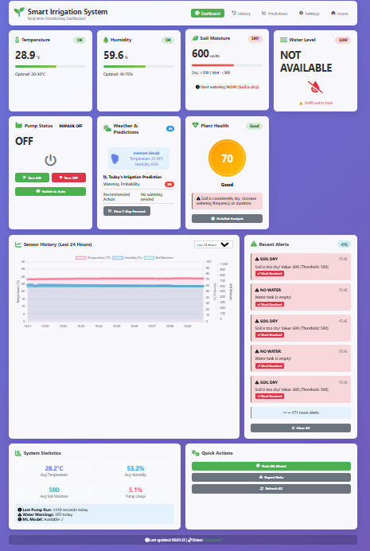
In automatic mode, the backend evaluates:
- Current soil moisture levels
- Machine learning prediction output
- Weather conditions
- Water tank availability
The pump is activated only when necessary, preventing overwatering and conserving water.
Weather Integration
Weather information is periodically fetched using a weather API. Data such as rainfall probability, humidity forecasts, and temperature predictions are stored and used to suppress watering during high-moisture or rainy conditions.
Alert Management
The system generates alerts under critical conditions such as:
- Extremely dry soil
- High temperature
- Low humidity
- Empty water tank
Alerts are stored in the database and can be sent via email notifications to inform users in real time.

- Machine Learning Model Integration
Machine learning models are integrated directly into the backend to enable low-latency real-time prediction.
Model Training
Historical sensor and watering data stored in the database are used to train supervised learning models. Feature engineering includes:
- Time-based features
- Rolling moisture averages
- Interaction terms
- Lag-based features
Ensemble models such as Random Forest and Gradient Boosting are used due to their robustness and high predictive performance.
Model Deployment
Trained models are serialized and loaded into memory during application startup to reduce inference latency. The same preprocessing pipeline used during training is applied during real-time inference.
Prediction Logic
The model predicts watering probability based on current and forecasted environmental conditions. If the probability exceeds a configurable threshold, watering is recommended and the pump duration is determined accordingly.
Auto-Training Mechanism
An automated scheduler periodically checks for newly accumulated sensor data and retrains the model when sufficient new samples are available. Performance metrics such as accuracy and error rate are logged to monitor model quality and prevent degradation.

- Database Design and Logging
SQLite serves as the primary storage engine. The database includes structured tables for:
- Sensor readings
- Watering history
- Weather information
- Machine learning training logs
- Prediction outputs
- Alert records
- Configuration settings
This structured design enables efficient real-time dashboard updates, long-term trend analysis, and future model optimization. Prediction results can also be exported as CSV files for offline evaluation and reporting.

- Frontend Implementation
The frontend provides a user-friendly interface for homeowners to monitor and control the plant care system. It is developed using HTML, CSS, and JavaScript.

Fig. 2. Smart Home Plant Monitoring Dashboard with Real-Time Control Interface
Frontend features include:
- Real-time display of soil moisture, temperature, and humidity
- Live pump status monitoring
- Visualization of watering history and alerts
- Access to machine learning-based watering predictions
- System configuration and manual override controls
JavaScript communicates with the backend using asynchronous API calls, enabling dynamic updates without page reloads. Visual indicators such as watering probability levels and recommendation labels assist users in understanding system decisions clearly.
.

- RESULTS AND DISCUSSION

The proposed ML-based Smart Home IoT Plant Care System was evaluated using real-time sensor data collected over multiple operational cycles in an indoor and balcony plant environment. The performance analysis focused on watering decision accuracy, water usage efficiency, prediction reliability, system responsiveness, and overall operational stability. The system was tested under varying indoor environmental conditions, including fluctuations in soil moisture, temperature, humidity, and weather forecasts.

- Watering Decision Accuracy
The machine learning models demonstrated a strong ability to distinguish between conditions that required watering and those that did not. By analyzing historical soil moisture patterns, environmental parameters, and time-based features, the system accurately predicted watering necessity with high consistency.
Compared to traditional threshold-based watering methods, the proposed system significantly reduced unnecessary pump activation. The classification models achieved improved precision in identifying genuinely dry soil conditions, ensuring that watering was applied only when required. This minimized overwatering and helped maintain optimal soil moisture levels for healthy plant growth.

- Water Usage Efficiency
A primary objective of the system was to optimize water consumption in a residential environment. Experimental results indicate a noticeable reduction in water usage due to intelligent prediction of watering events.The integration of weather forecasts further improved efficiency by suppressing watering during high-humidity or rainy conditions. Additionally, automated pump duration control adjusted watering time proportionally based on soil dryness levels instead of using fixed-duration watering. This adaptive mechanism significantly reduced water wastage and prevented soil oversaturation.

- Prediction Reliability and Stability
The machine learning models maintained stable predictive performance over time despite variations in indoor environmental conditions. The use of ensemble learning techniques enabled the system to capture nonlinear relationships among soil moisture, temperature, and humidity parameters.The auto-training mechanism periodically retrained the models using newly collected sensor data. This continuous learning capability allowed the system to adapt to seasonal changes and long-term indoor environmental shifts, improving prediction consistency and reducing model degradation.

- System Response Time and Real-Time Performance
The system demonstrated low-latency performance suitable for real-time smart home deployment. Sensor data ingestion, prediction computation, and pump control decisions were executed within short time intervals, ensuring immediate response to soil dryness.
The Flask-based backend efficiently handled multiple API requests without noticeable delays. Since trained models were loaded into memory during application startup, inference time remained minimal, allowing seamless real-time operation.

- Plant Health and Soil Stability Analysis
Analysis of soil moisture trends showed improved stability compared to manual or rule-based watering methods. The system maintained soil moisture within optimal ranges for extended durations, reducing sharp fluctuations that can stress plant roots.By maintaining balanced watering frequency and duration, the system supported healthier root development and minimized risks associated with overwatering or prolonged dryness. The correlation between environmental conditions and watering actions confirmed the effectiveness of the predictive strategy.

- Alert Accuracy and System Reliability
The alert mechanism successfully detected critical conditions such as:
- Extremely dry soil
- High indoor temperature
- Low humidity
- Low water tank level
Alerts were generated promptly, logged in the database, and optionally sent via email notifications. The system demonstrated stable continuous operation without data loss or critical failures during testing. Background processes such as weather updates and model retraining operated concurrently without interrupting core watering functionality.

- Comparative Performance Analysis
When compared with conventional threshold-based plant watering systems, the proposed ML-based approach demonstrated superior performance in terms of:
- Watering decision accuracy
- Water conservation
- Adaptability to environmental changes
- Long-term stability
Traditional systems rely on fixed moisture thresholds, while the proposed system leverages historical trends and predictive analytics to make informed watering decisions. This intelligent integration of IoT sensing and machine learning enhances automation efficiency and improves overall plant care quality.
Overall, the results confirm that integrating IoT monitoring with machine learning-based prediction significantly improves smart home plant watering efficiency, system intelligence, and operational reliability.

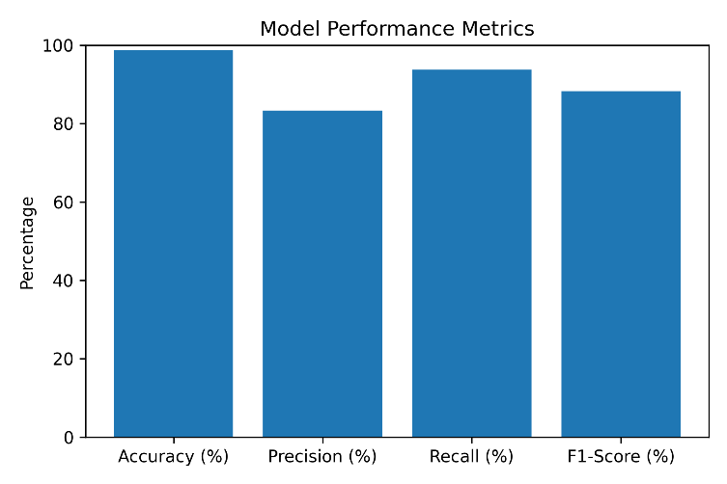
Fig. 3. Performance Metrics of the Proposed Model

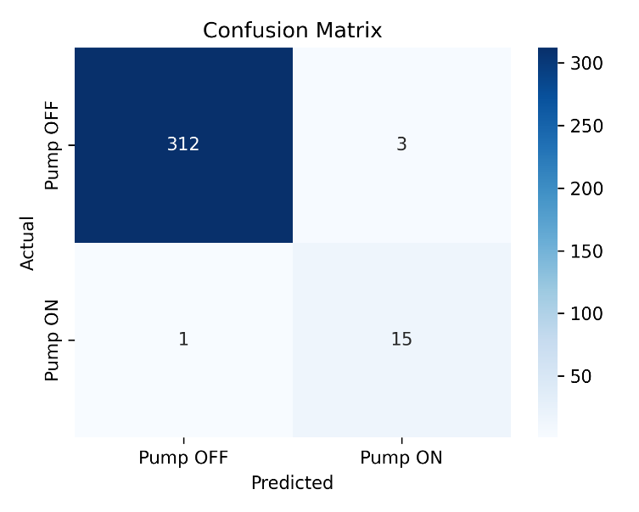
Fig.4. Confusion Matrix of the Proposed Random Forest Model

- CONCLUSION

This research presents an intelligent IoT-based Smart Home Plant Care System integrated with machine learning for predictive watering management and plant health monitoring. By combining real-time sensor data, weather information, and ML-based prediction, the system enhances watering accuracy, improves water efficiency, and reduces manual effort in maintaining indoor and balcony plants.The proposed system overcomes the limitations of traditional threshold-based watering methods by incorporating predictive analytics and adaptive control mechanisms. Automated pump activation, weather-aware logic, and real-time monitoring through a Flask-based web interface ensure consistent soil moisture maintenance and healthier plant growth.
The framework is scalable, cost-effective, and well-suited for smart home environments. Its modular architecture allows easy integration of additional sensors and advanced analytics. Future work may include the integration of deep learning models for enhanced prediction accuracy, mobile application development, voice assistant integration, cloud-based multi-user deployment, and plant-specific customization for different plant species.

References.
- L. D. Xu, W. He, and S. Li, “Internet of Things in industries: A survey,” IEEE Transactions on Industrial Informatics, vol. 10, no. 4, pp. 2233–2243, 2014.
- M. Ayaz, M. Ammad-Uddin, Z. Sharif, A. Mansour, and E. M. Aggoune, “Internet-of-Things based smart agriculture: Toward making the fields talk,” IEEE Access, vol. 7, pp. 129551–129583, 2019.

- P. P. Ray, “Internet of Things for smart agriculture: Technologies, practices and future direction,” Journal of Ambient Intelligence and Smart Environments, vol. 9, no. 4, pp. 395–420, 2017.
- K. G. Liakos, P. Busato, D. Moshou, S. Pearson, and D. Bochtis, “Machine learning in agriculture: A review,” Sensors, vol. 18, no. 8, 2018.
- S. R. García, F. J. Martínez, and J. A. López, “Predictive irrigation management using machine learning,” Agricultural Water Management, vol. 240, 2020.
- M. A. Rahman, M. S. Islam, M. A. Hossain, and M. M. Hasan, “Smart irrigation system using IoT and machine learning techniques,” International Journal of Advanced Computer Science and Applications, vol. 11, no. 6, 2020.
- “Smart Plant Monitoring and Automated Irrigation System Using IoT,” ResearchGate, 2024.
- “IoT-Based Automated Irrigation and Fertilization System Using Arduino,” ResearchGate, 2024.
- “Smart Plant Monitoring System Using IoT,” ResearchGate, 2024.
- “Cloud-Based IoT System for Plant Health Monitoring,” IEEE Xplore Digital Library, 2024.
- “Smart Plant Monitoring System Using IoT and Blynk,” International Journal of Scientific Research in Engineering and Management, 2024.
- “IoT-Enabled Plant Protection Employing Design Thinking for Effortless Growth,” Agriculture Journal, vol. 13, no. 1.
- “Cloud-Based IoT Architecture for Smart Monitoring Applications,” Future Generation Computer Systems, vol. 93, pp. 58–67, 2019.
- Kamilaris and F. X. Prenafeta-Boldú, “Deep learning in agriculture: A survey,” Computers and Electronics in Agriculture, vol. 147, pp. 70–90, 2018.
- R. S. Ferentinos, “Deep learning models for plant disease detection and diagnosis,” Computers and Electronics in Agriculture, vol. 145, pp. 311–318, 2018.
- J. Ruiz-Garcia, L. Lunadei, P. Barreiro, and J. I. Robla, “A review of wireless sensor technologies and applications in agriculture and food industry,” Computers and Electronics in Agriculture, vol. 74, no. 1, pp. 2–20, 2011.
- S. R. Pantazi, D. Moshou, and A. Tamouridou, “Automated detection of crop stress using machine learning techniques,” Computers and Electronics in Agriculture, vol. 156, pp. 96–104, 2019.
- “Smart Home IoT-Based Plant Monitoring System,” Journal of Information and Communication Systems.
- “A Data-Driven IoT Framework for Smart Plant Health Monitoring,” PLOS ONE, 2024.
- “IoT-Based Smart Plant Care and Monitoring System,” International Engineering Journal for Research and Development.

